**INTRODUCTION**

**1.1 Overview**

**• Event management is the process of creating and maintaining an event. This process spans from the very beginning of planning all the way to post-event strategizing.**

**• At the start, an event manager makes planning decisions, such as the time, location, and theme of their event.**

**• During an event, event managers oversee the event live and make sure things run smoothly.**

**1.2 Purpose**

**• The project aim is to provide real-time knowledge for all the students who have basic knowledgeof Salesforce and Looking for a real-time project.**

**• This project will also help to thoseprofessionals who are in cross-technology and wanted to switch to Salesforce with the help ofthis project they will gain knowledge and can include into their resume as well.**

**PROBLEM DEFINITION &DESIGN THINKING**

**2.1 Empathy Map**

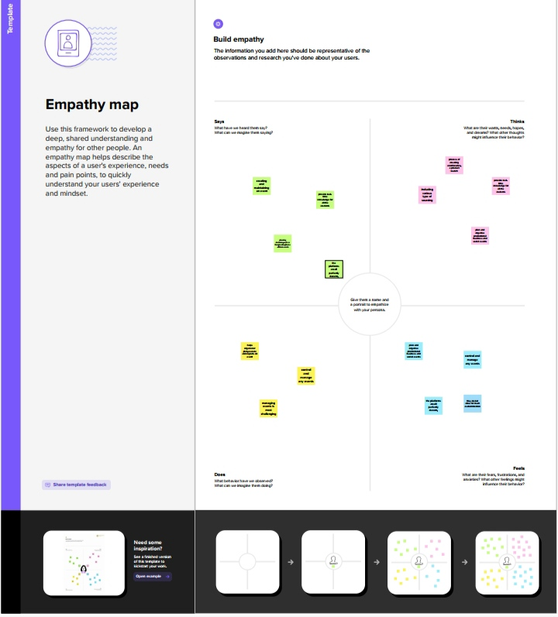

**2.1Ideation& Brainstroming Map**

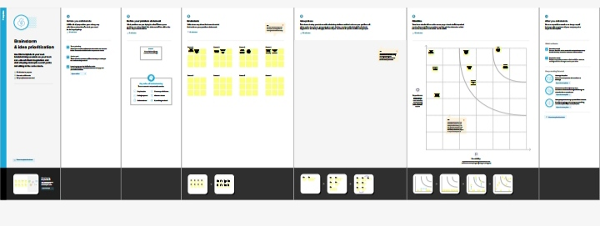

**RESULT**

**3.1 Data Type**

|  |  |  |
| --- | --- | --- |
| **Object Name** | **Field in the Object** |  |
|  | **Field Label** | **Data Type** |
| **Enter city** | **Enter city** | **Text09** |
| **Enter start Date** | **Enter start date** | **Date/Time** |
| **Name** | **Event Name** | **Text80** |
| **Ownerid** | **Owner** | **Look up user** |

**3.2Activity&Screenshot**

**Salesforce**

**Salesforce is your customer success platform, designed to help you sell, service, market, analyze, and**

**connect with your customers.**

**Creation of Salesforce platform**

**Go to Developer. Salesforce.com and click on sign up, Ender our details as Name,Email, role, company etc. Email is send to your mail id**

**Go to the inbox of the email that you used while singing up. Click on the verify account to activate your account.**

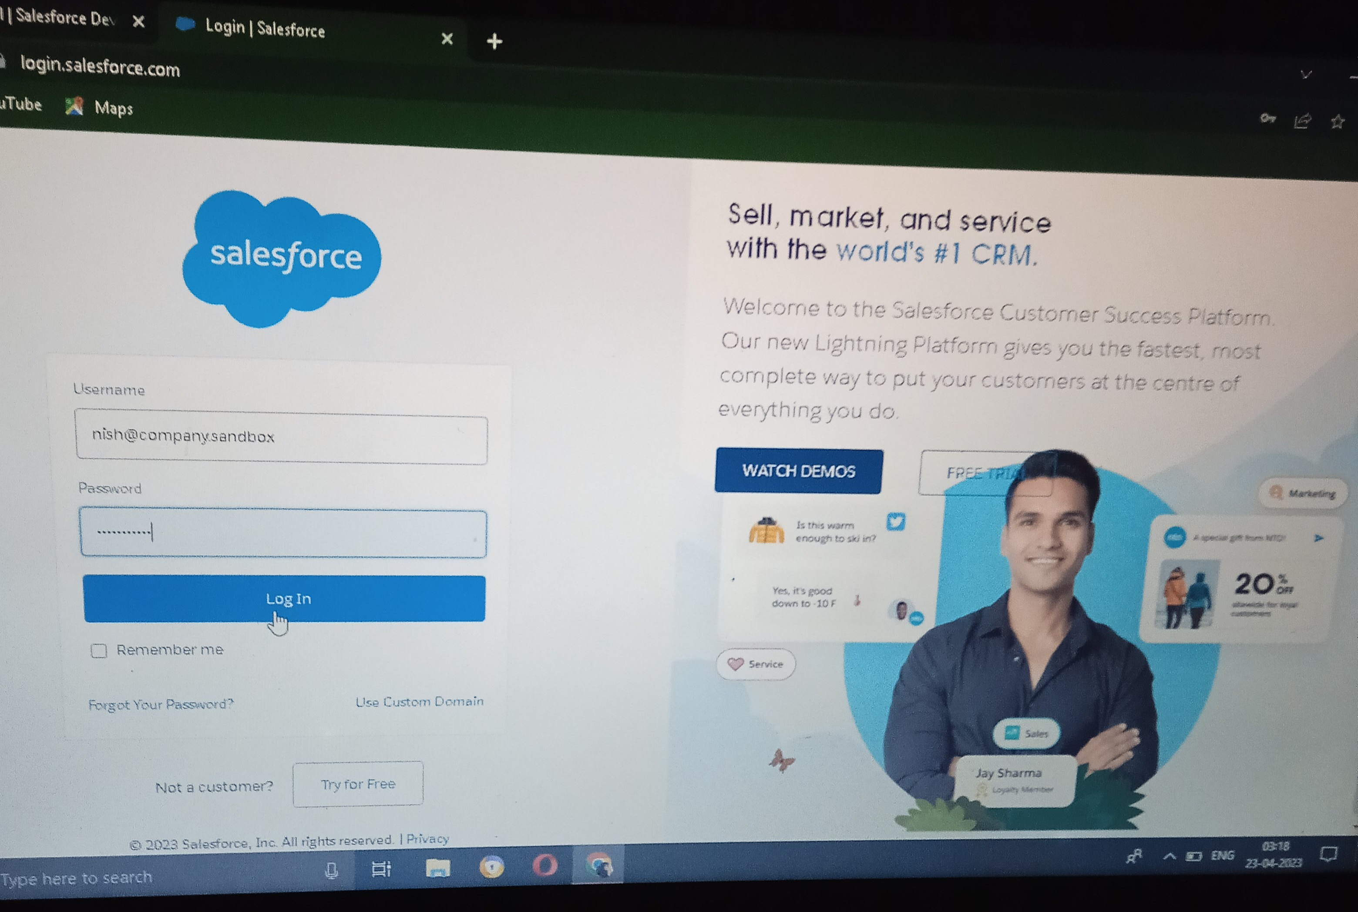

**The setup page will appear as below.**

**Milestone 2-Object**

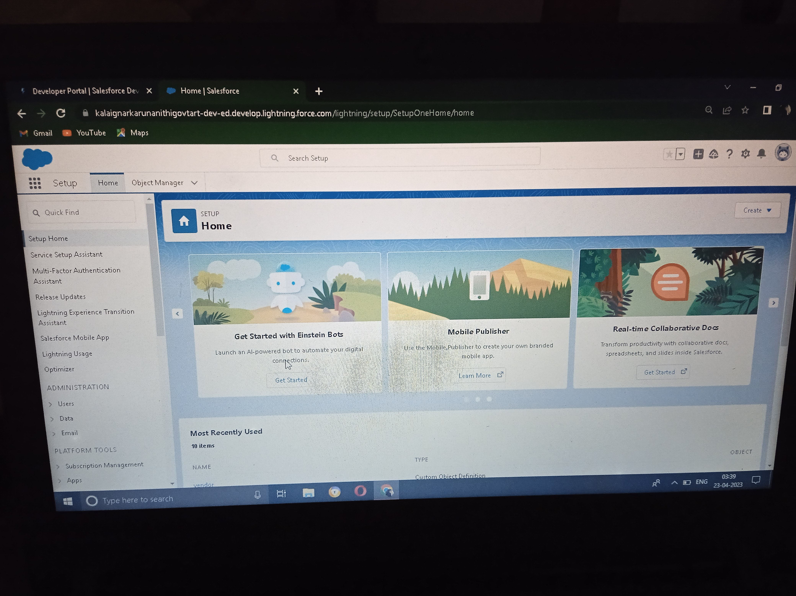

**The Setup page Will appear as below**

**After the above steps, have a look on the extreme right you will find a Create**

**Dropdownclick on that and select Custom Object.**

**● On the Custom Object Definition page, create the object as follows:**

**● Label: Event**

**● Plural Label: Events**

**● Record Name: Event Name**

**● Check the Allow Reports checkbox**

**● Check the Allow Search checkbox**

**Then save it**

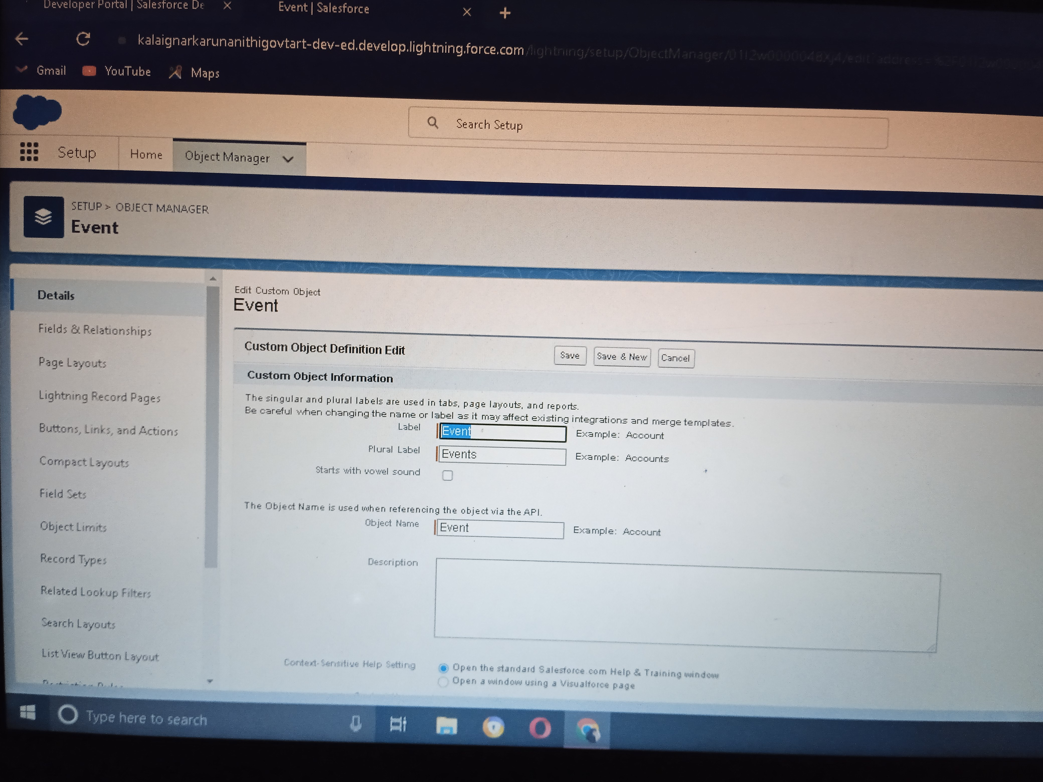

**Attendees Object, Vendor And Speaker Object Create Like This**

**Milestone 3 -Object**

**Creation of Event tab:**

**Now create a custom tab.**

**1. Click on Home tab, enter Tabs in Quick Find and select Tabs.**

**2. Under custom object tabs, click New**

**3.For Object select Event.**

**4. For Tab Style, select any icon.**

**5. Leave all defaults as is. Click Next, Next, and Save.**

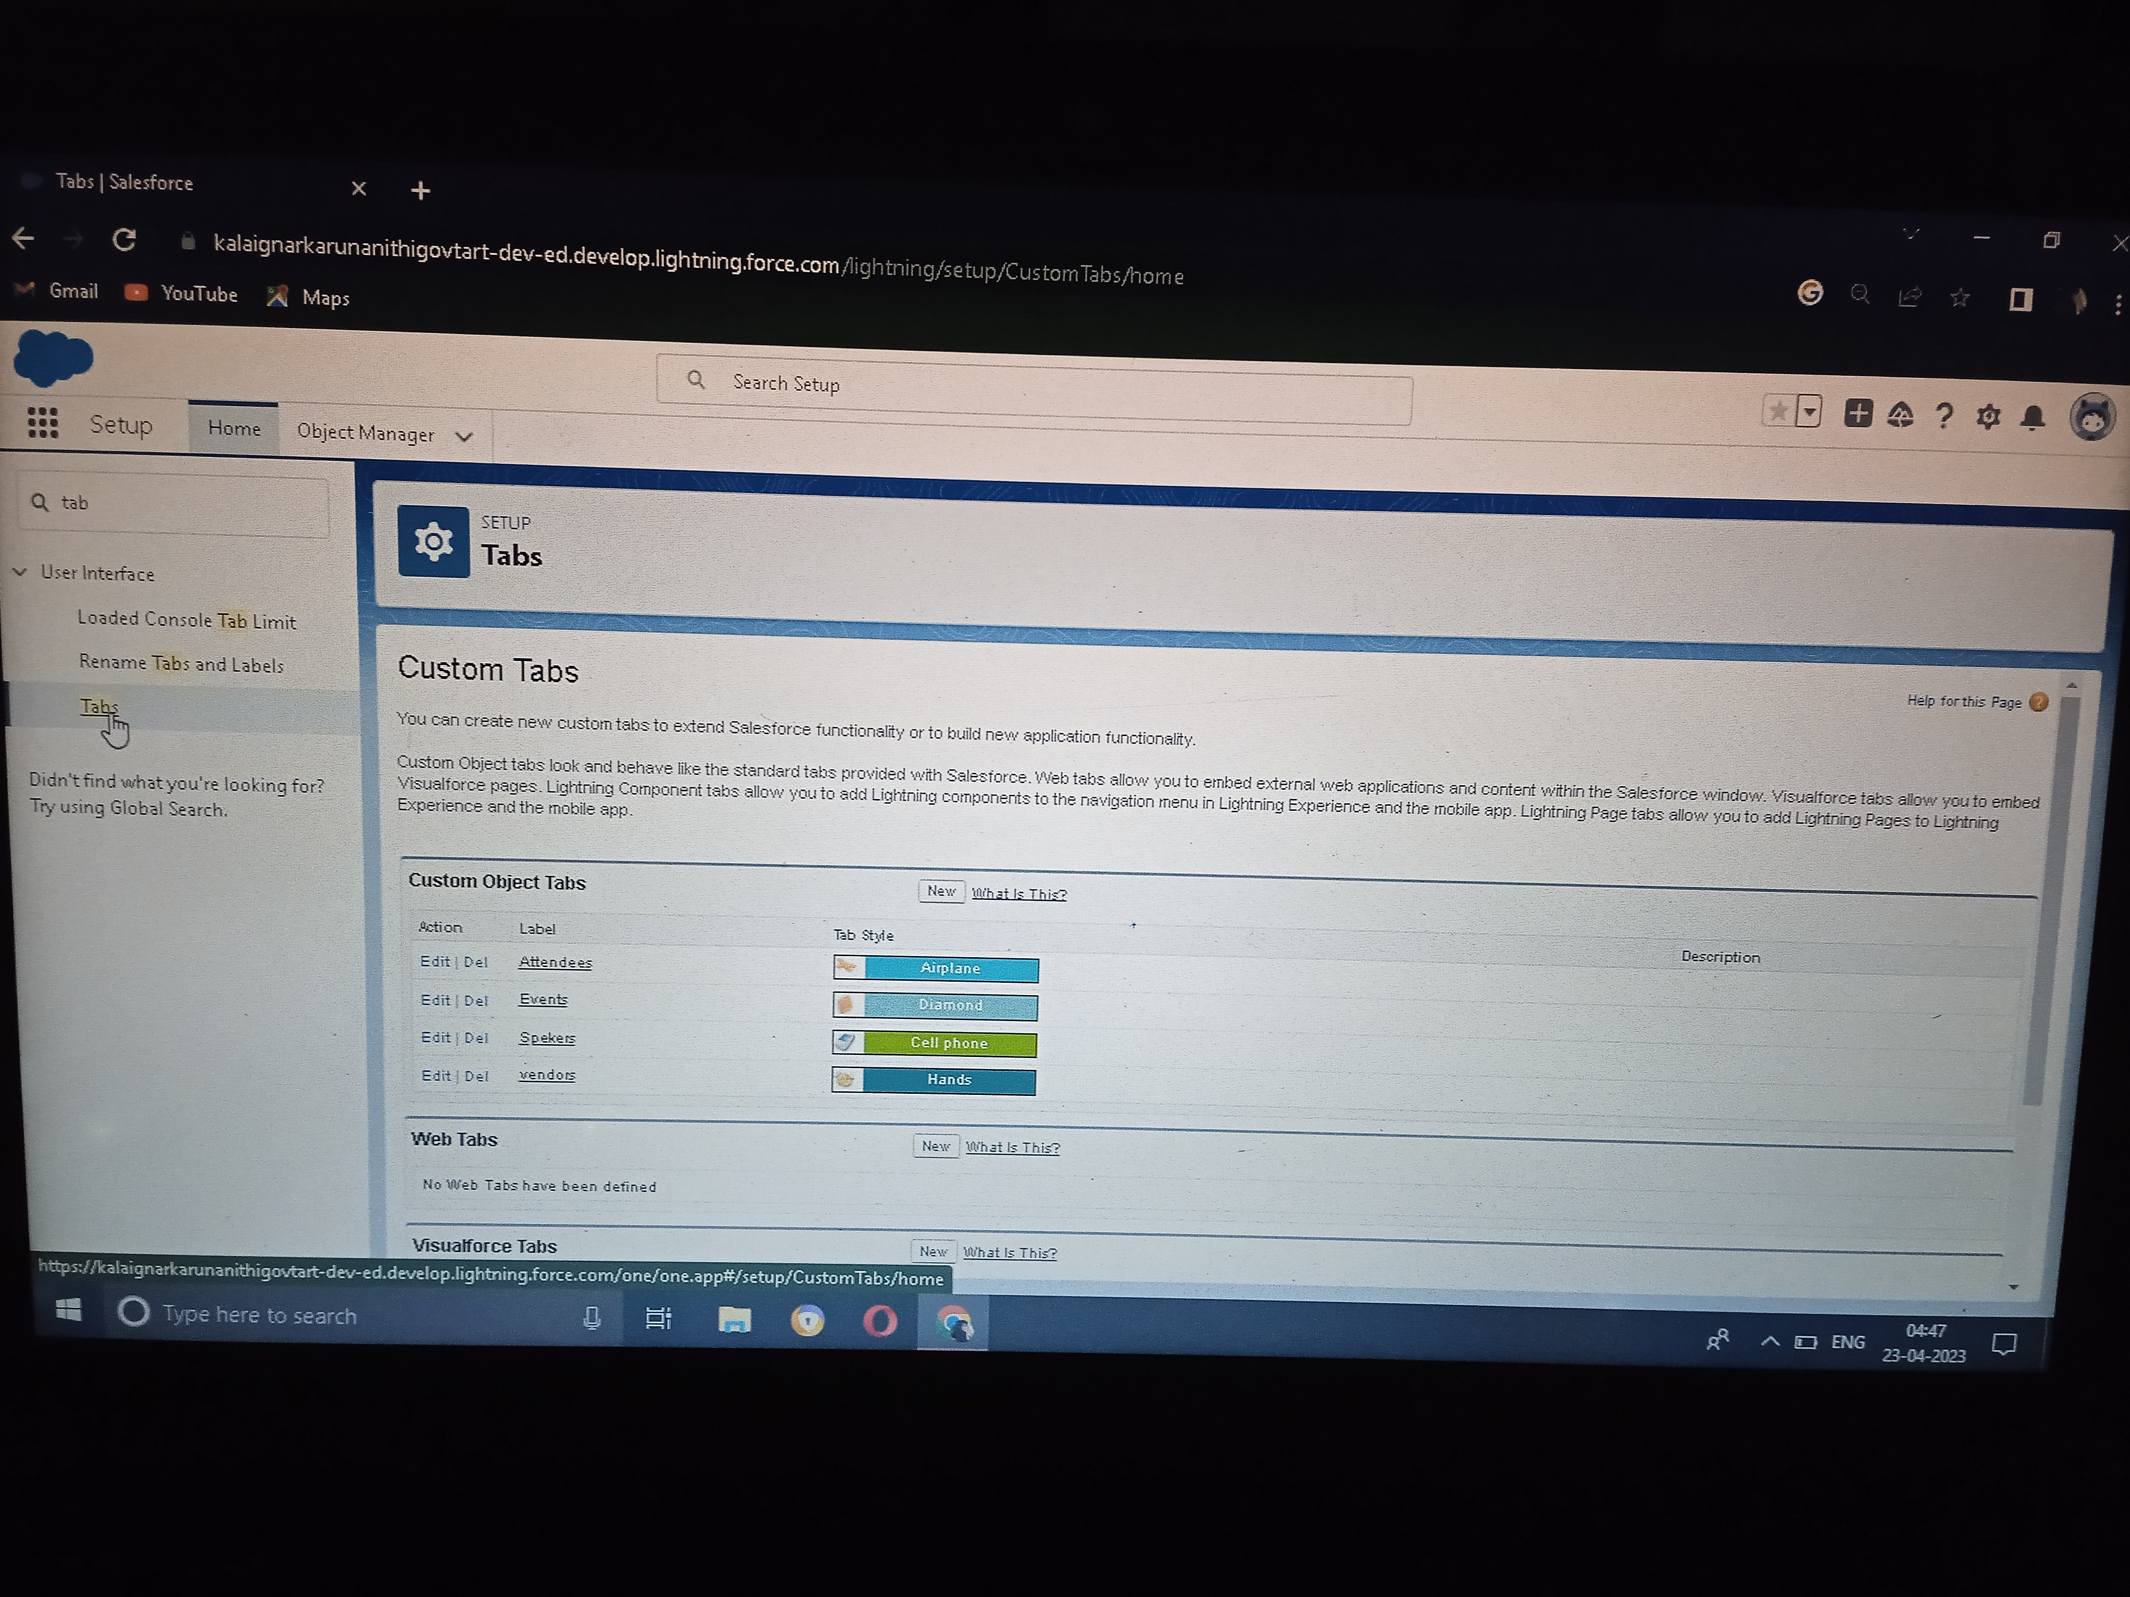

**Then Attendees tab, Vendor tab And Speaker tab Created like this**

**Milestone 3 – Application:**

**Create the Event Management Construction app**

**● From Setup, enter App Manager in the Quick Find and select App Manager.**

**● Click New Lightning App. Enter Event Management as the App Name, then click Next**

**● Under App Options, leave the default selections and click Next.**

**● Under Utility Items, leave as is and click Next.**

**● From Available Items, select Events, Attendees, speakers, vendors, Reports,**

**andDashboards and move them to Selected Items. Click Next.**

**● From Available Profiles, select System Administrator and move it to Selected Profiles.**

**Click and Save**

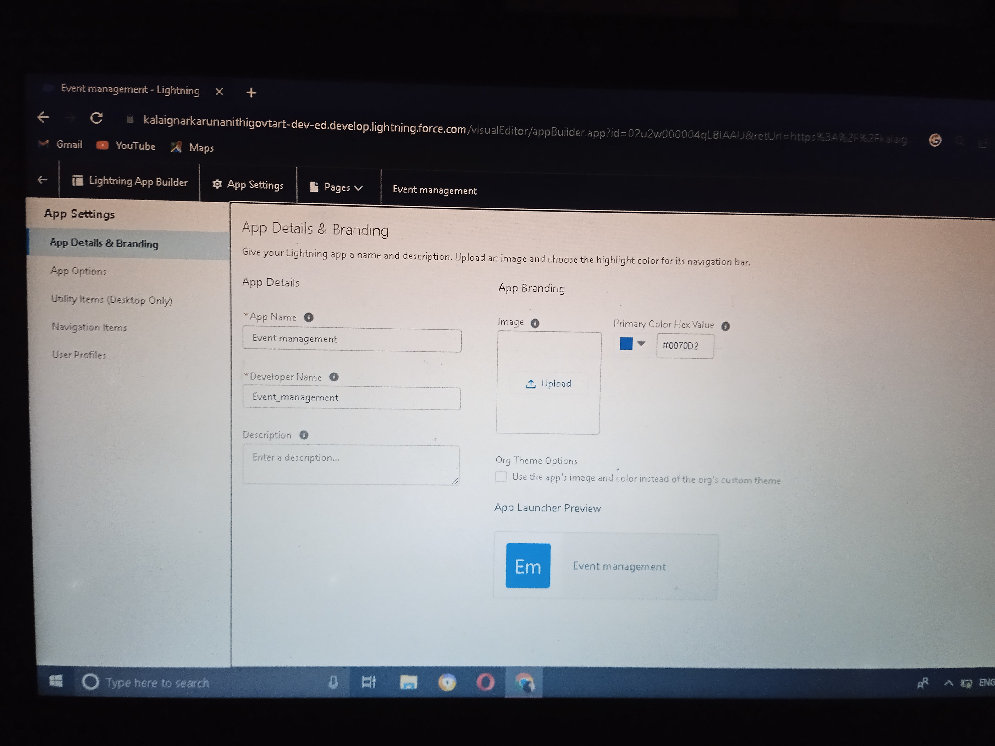

**Milestone 4 – Fields:**

**Creation of fields for the Event objects:**

**1. click the gear icon and select Setup. This launches Setup in a new tab.**

**2. Click the Object Manager tab next to Home.**

**3. Select Event.**

**4. Select Fields & Relationships from the left navigation, and click New**

**Now we’re ready to make a custom field. Let’s do this!**

**5. Select the Text as the Data Type, then click Next.**

**6. For Field Label, enter City.**

**7. Click Next, Next, then Save & New**

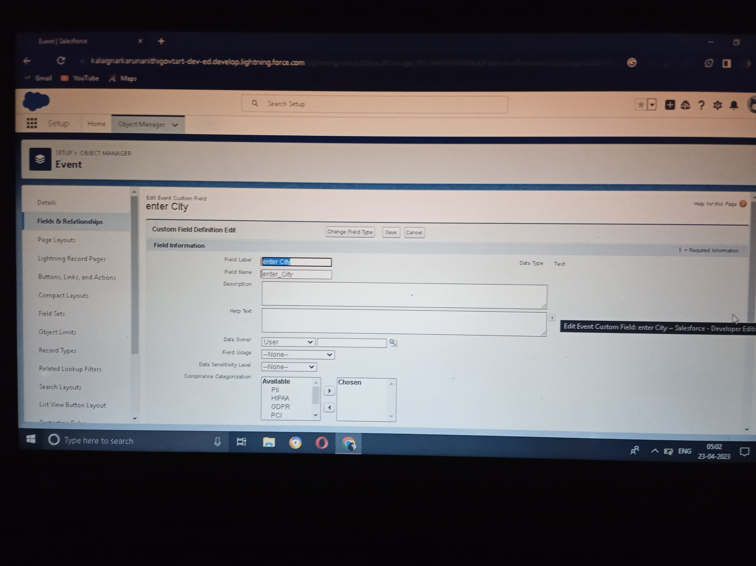

**Creation of fields for the Attendees objects:**

**1. Select the Auto number as the Data Type, then click Next.**

**2. For Field Label, enter Id.**

**3. Click Next, Next, then Save & New**

**4. Select the phone as the Data Type, then click Next.**

**5. For Field Label, Phone.**

**6. Click Next, Next, then Save & New.**

**7. Select the Email as the Data Type, then click Next.**

**8. For Field Label, enter Email.**

**9. Click Next, Next, then Save & New.**

**10. From Setup, click Object Manager and select Student.**

**11. Click Fields & Relationships, then New.**

**12. Select Picklist as the Data Type and click Next.**

**13. For Field Label enter Tickets.**

**14. Select Enter values, with each value separated by a new line and enter these value**

**Then Click Next, Next, then Save & New**

**Creation of fields for the Speakers objects:**

**1. Select the Text Area as the Data Type, then click Next.**

**2. For Field Label, enter Bio.**

**3. Click Next, Next, then Save & New.**

**4. Select the Email as the Data Type, then click Next.**

**5. For Field Label, e-mail.**

**6. Click Next, Next, then Save & New**

**Let’s create a Look-up relationship with Event object**

**1. Select Look-up Relationship as the Data Type and click Next.**

**2. For Related to, enter Event.**

**3. Click Next.**

**4. For Field Label, Event Name.**

**5. Click Next, Next, Next and Save.**

**Creation of fields for the Vendors objects:**

**1. Select the Email as the Data Type, then click Next.**

**2. For Field Label, e-mail.**

**3. Click Next, Next, then Save & New.**

**4. Select the phone as the Data Type, then click Next.**

**5. For Field Label, Phone.**

**6. Click Next, Next, then Save & New.**

**7. Select the Email as the Data Type, then click Next.**

**8. For Field Label, e-mail.**

**9. Click Next, Next, then Save & New**

**10. Select the Text as the Data Type, then click Next.**

**11. For Field Label, enter Service Provider.**

**12. Click Next, Next, then Save & New.**

**13. Select Look-up Relationship as the Data Type and click Next.**

**14. For Related to, enter Event.**

**15. Click Next.**

**16. For Field Label, Event Name.**

**17. Click Next, Next, Next and Save.**

**Milestone 5 – Profile:**

**Creation on profile:**

**1. From Setup enter Profiles in the Quick Find box, and select Profiles.**

**2.From the list of profiles, find Standard User.**

**3. Click Clone.**

**4.For Profile Name, enter Event user profile.**

**5. Click Save.**

**6. While still on the Event profile page, then click Edit.**

**7.Scroll down to Custom Object Permissions and Give view all access permissions to the**

**Attendees, speakers and vendors.**

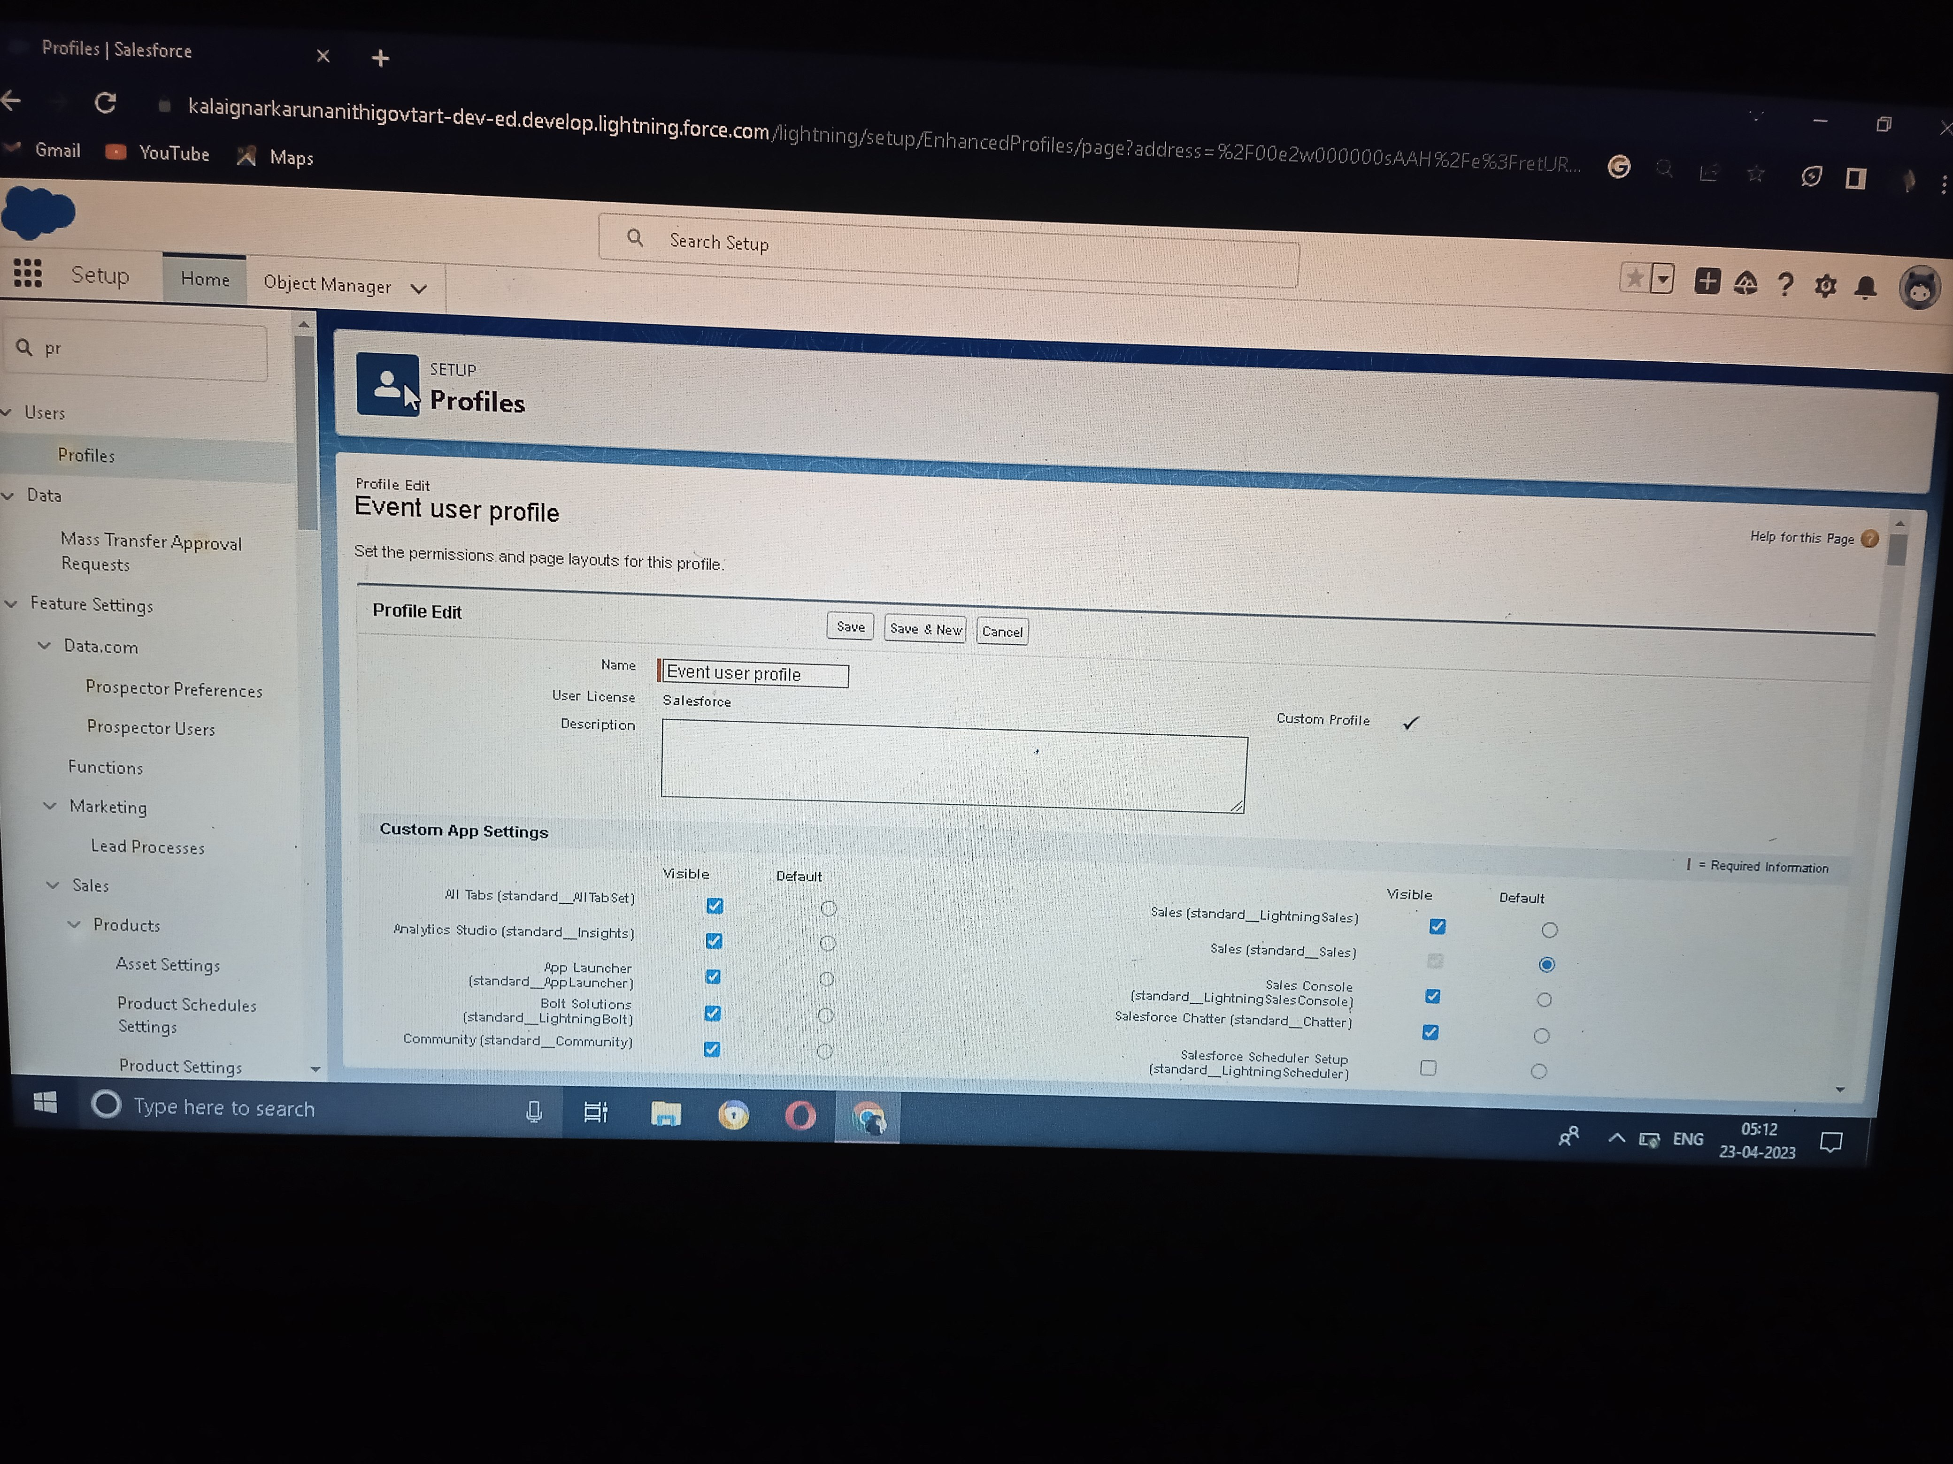

**Then Create Profile Event Vendor Profile Like This**

**Milestone 6 – User:**

**Creating a User:**

**From setup type “users” in quick find and select users, then click New User**

**• First Name: manju**

**• Last Name: Gupta**

**• Alias: manj**

**• Email: provide your personal email id for future reference**

**• Username: manjugupta@thesmartbridge.com**

**• Nickname: manju**

**• Role: leave it as default**

**• User License: Salesforce**

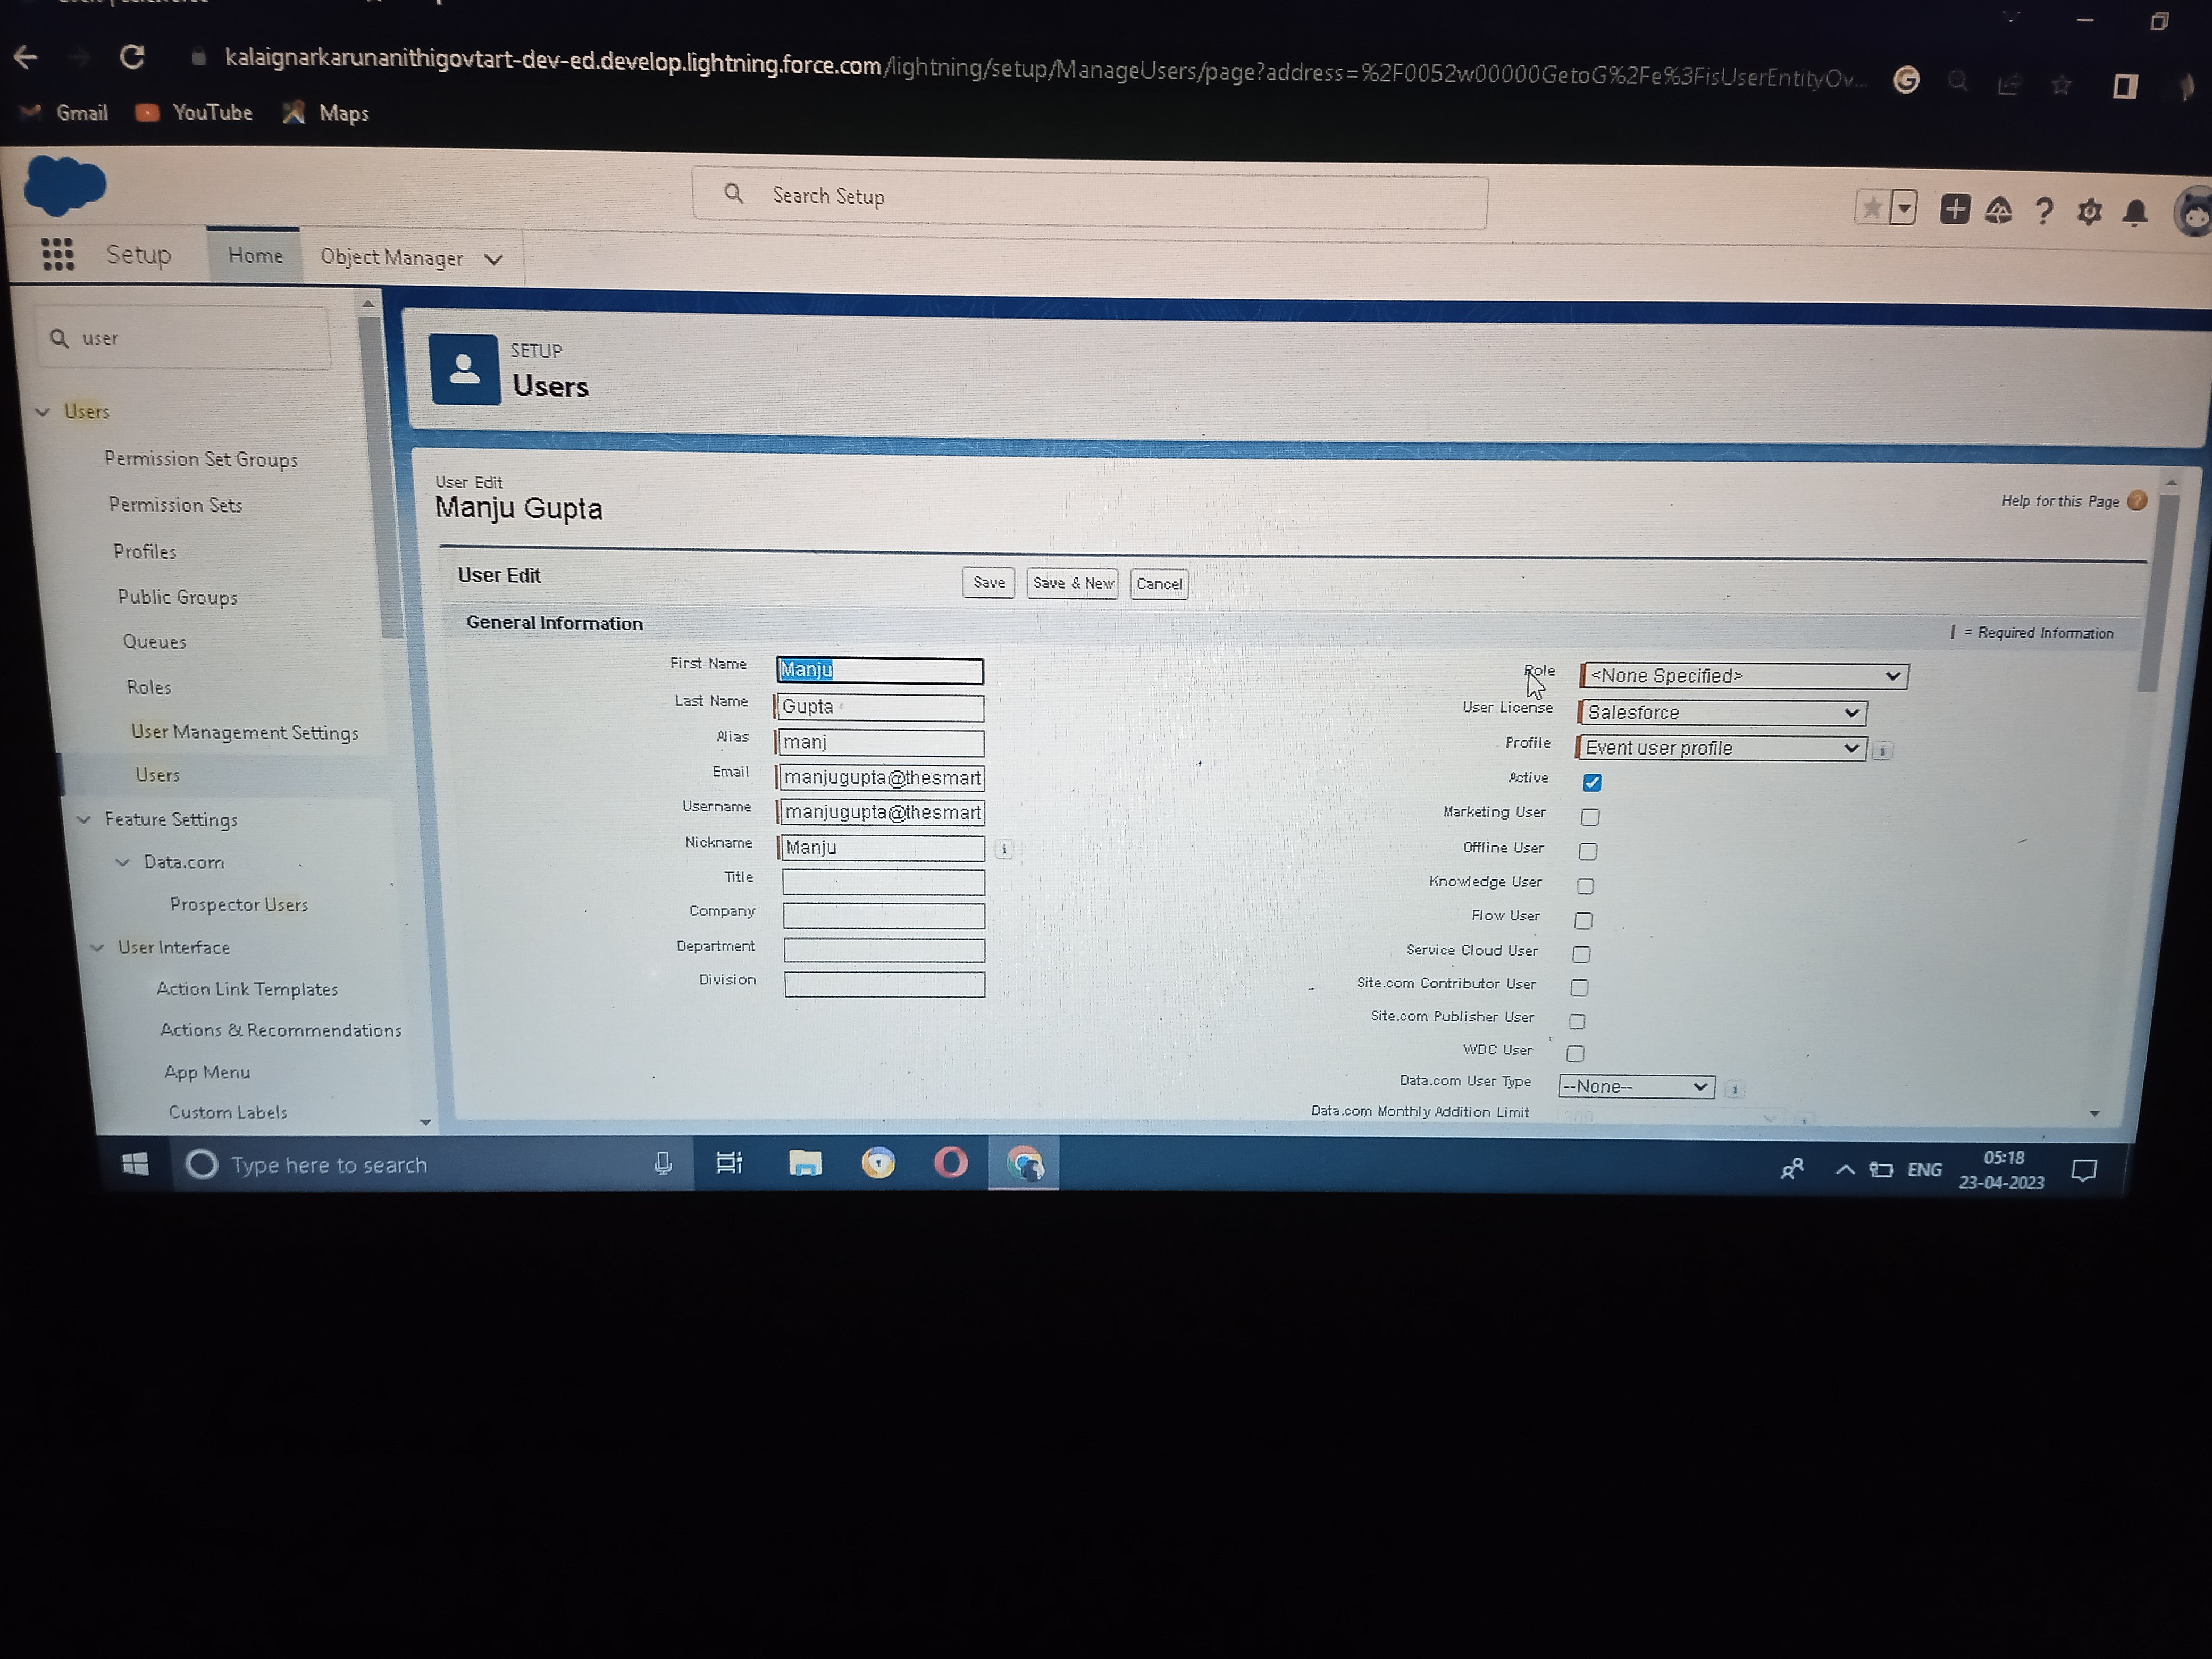

**Milestone 7 – Permission sets:**

**Creating a Permission Set:**

**• From setup search “permission sets” in quick find and select permission set then click on new**

**• Enter label as: Event Permits and Save.**

**• After saving the permission click on the Manage assignment**

**• Now click on the Add Assignment**

**• Now select the users and click on save**

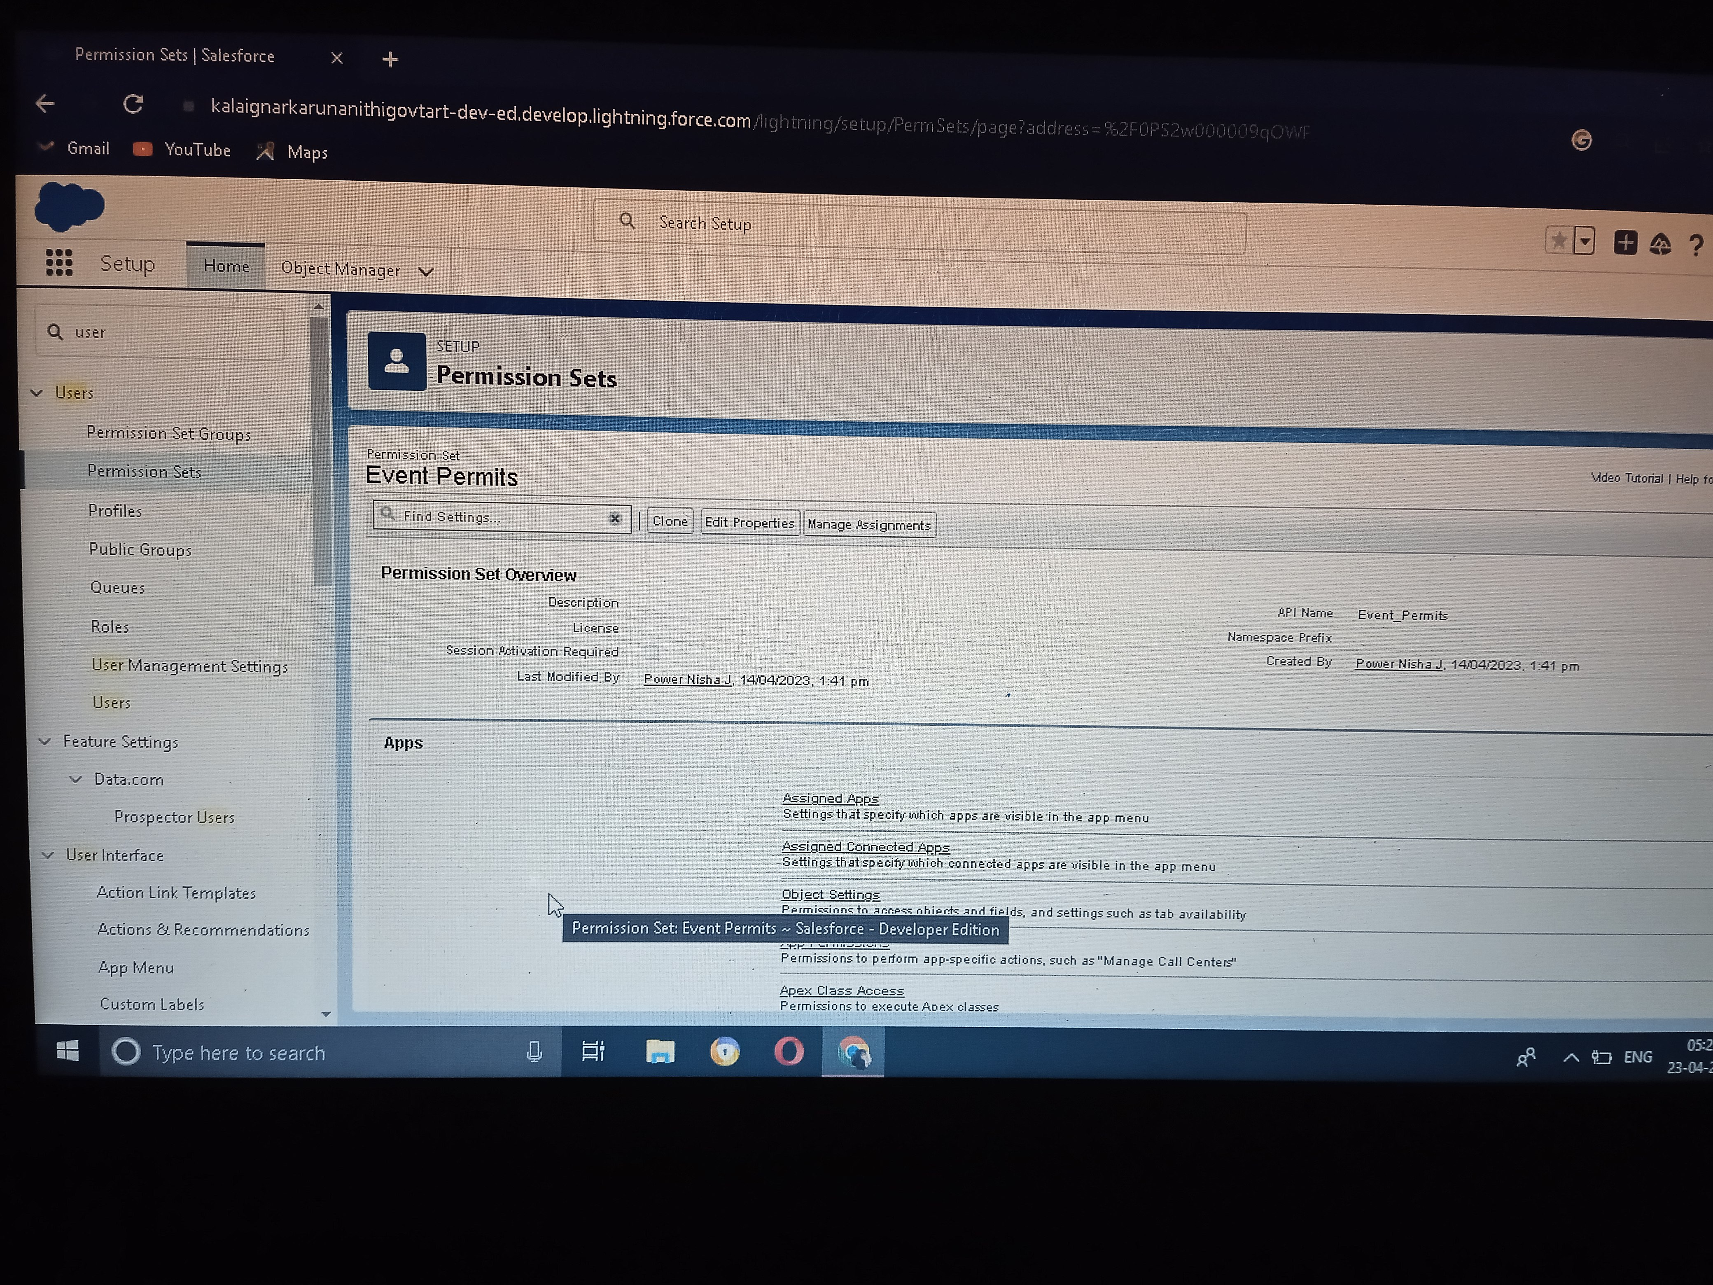

**Milestone 8 - Reports**

**Creating a Report:**

**1. From the Reports tab, click New Report.**

**2.Select the report type Attendees with events for the report, and click Create.**

**3. Customize your report accordingly and include all fields, then save or run it.**

**Trailhead Profile URL Link**

**Team leader:**

**<https://trailblazer.me/id/paras196>**

**Team Member 1:**

**<https://trailblazer.me/id/pavus3>**

**Team Member 2:**

**<https://trailblazer.me/id/powej>**

**Team Member:3**

**<https://trailblazer.me/id/prabr24>**

**ADVANTAGE**

**Opportunities for creativity**

**Ability to work on different events.**

**Chance to work with diverse clients**

**Collaborative work environment.**

**High projections for job growth.**

**Few educational requirements**

**Unconventional work hours**

**APPLICATION**

**Apps in Salesforce are a group of tabs that help the application function by working together as**

**a unit. It has a name, a logo, and a particular set of tabs. The simplest app usually has just two**

**tabs.**

**There are 2 types of Salesforce applications:**

**• Standard apps: these apps come with every occurrence of Salesforce as default.**

**Community, Call Center, Content, Sales, Marketing, Salesforce Chatter, Site.com, and**

**App Launcher are included in these apps. The description, logo, and label of a standard**

**app cannot be altered.**

**• Custom apps: these apps are created according to the needs of a company. They can be**

**made by putting custom and standard tabs together. Logos for custom apps can be**

**changed.**

**CONCLUSION**

**Salesforce has everything you need to run your business from anywhere. Using standard products**

**and features, you can manage relationships with prospects and customers, collaborate and engage**

**with employees and partners, and store your data securely in the cloud.**

**FUTURE SCOPE**

**The scope of event management as a career in India is immense. This career provides a unique opportunity to rephrase our social beliefs. Hosting events can redesign the structure of a city by facilitating economic growth, employment opportunities, urban development, and promoting indigenous culture and heritage.**